|  |  |
| --- | --- |
|  | 2018 Final ReportSummary Sheet |

|  |  |  |  |  |  |  |  |  |
| --- | --- | --- | --- | --- | --- | --- | --- | --- |
| Grantee Information | | | | | | | | |
| |  |  | | --- | --- | | **Project Title:** | Tracking soil nitrogen and availability | | | | | | | | | |
| |  |  | | --- | --- | | **Institution:** | University of Illinois | | **Primary Investigator**: | Nafziger | | | | | | | | | |
| |  |  | | --- | --- | | **NREC Project #** | 2015-3-360422-56 | | | | | | | | | |
|  |  | |  |  | | | | |
| **Is your project on target from an IMPLEMENTATION standpoint?** | | | | |  | **Yes** |  | **No** |
| **If you answered “no” please explain:** | | | | |  |  |  |  |
| |  | | --- | |  | | | | | | | | | |
| **Is your project on target from a BUDGET standpoint?** | | | | |  | **Yes** |  | **No** |
| **If you answered “no” please explain:** | | | | |  |  |  |  |
|  | | | | | | | | |
| |  |  |  |  |  | | --- | --- | --- | --- | --- | | **Based on what you know today, will you meet the objectives of your project on-time and on-budget?** |  | **Yes** |  | **No** | | | | | | | | | |
| |  |  |  |  |  | | --- | --- | --- | --- | --- | | **If you answered “no” please explain:** |  |  |  |  | | |  | | --- | |  | | | | | | | | | | | | | | |
| |  |  |  |  |  | | --- | --- | --- | --- | --- | | **Have you encountered any issues related to this project?** |  | **Yes** |  | **No** | | | | | | | | | |
| |  |  |  |  |  | | --- | --- | --- | --- | --- | | **If you answered “yes” please explain:** |  |  |  |  | | |  | | --- | |  | | | | | | | | | | | | | | |
| |  |  |  |  |  |  | | --- | --- | --- | --- | --- | --- | | |  |  |  |  |  | | --- | --- | --- | --- | --- | | **Have you reached any conclusions related to this project that you would like to highlight?** |  | **Yes** |  | **No** | | | |  |  |  |  |  | | --- | --- | --- | --- | --- | | **If you answered “yes” please explain:** |  |  |  |  | | |  | | --- | | Soil N levels are resilient –heavy June rainfall in 2015 and heavy rainfall in late April-early May in 2017 resulted in little measurable “loss” of N from the soil, and resulted in little or no yield loss. We have not been able to clearly delineate how much N needs to be in the soil at a certain crop growth stage to assure adequate N for the crop | | | | | | | | | | | | | | | |
| |  |  |  |  |  |  | | --- | --- | --- | --- | --- | --- | | |  |  |  |  |  | | --- | --- | --- | --- | --- | | **Have you completed any outreach activities related this project? Or do you have any activities planned?** |  | **Yes** |  | **No** | | | |  |  |  |  |  | | --- | --- | --- | --- | --- | | **If you answered “yes” please explain and provide details for any upcoming outreach:** |  |  |  |  | | |  | | --- | | Presented results from this numerous times in meetings and field days, wrote articles in the UI Bulletin, gave several webinars using findings from this research, and made a presentations at the American Society of Agronomy meeting in Baltimore, MD using data from this work. | | | | | | | | | | | | | | | |
| **Additional Notes:** | |  | | | | | | |
| The model and app developments by co-investigators (Drs. Pittelkow and Wang) are close to completion; reports showing progress on those two parts of the project are included at the end of the first report. | | | | | | | | |

**Tracking Soil Nitrogen Loss and Availability**

**Report for Year 4 (2018), Project 802 NREC 2015-02615, February 2019**

Emerson Nafziger and Cameron Pittelkow, Crop Sciences, Junming Wang, Illinois State Water Survey, and Dan Schaefer, IFCA

This project was initiated to use soil N data gathered under the N-Watch program and to generate new data on soil N trends following application of different forms and times of N application in small-plot trials at research centers and on farmer fields.

**N-Tracking Procedures in 2018**

N-tracking studies at three Illinois Crop Sciences Research & Education Centers and one on-farm site that replaced the trial previously at the REC near DeKalb were carried out as planned, with the following treatments: 1) 200 lb. N per acre as NH3 in the fall; 2) 200 lb. N per acre as NH3 without N-Serve; 3) 200 lb. N per acre as NH3 in the early spring (2 to 3 weeks before planting) without N-Serve; 4) 200 lb. N per acre as NH3 in the early spring with N-Serve; 5) 100 lb. N as NH3 in the fall with N-Serve + 50 lb. N as UAN at planting + 50 lb. N as UAN at sidedress (V5-V6); 6) 50 lb. N as UAN at planting + 150 lb. N as UAN at V5-V6 sidedress; 7) 100 lb. N as NH3 in the fall with N-Serve to provide a lower N rate (added in 2017); 8) A check without N fertilizer. These same treatments were applied as part of on-farm N rate trials at three sites, one each in McLean, Ford, and Christian Counties again in 2018.

We also established a trial with a different set of N treatments (no NH3 of fall-applied N) near Neoga, in Cumberland County, and sampled soil to track N in four treatments: zero N; 150 lb. N/acre as UAN injected at planting; and 50 lb. N as UAN injected at planting followed by 100 lb. N as UAN at V5-6 (5/29) or at V9 (6/19).

The following table provides dates for N applications and planting in 2018. May was very warm, and as a result, plants developed much more quickly than normal, with only about one month between planting and sidedress (V5-V6.)

|  |  |  |  |  |
| --- | --- | --- | --- | --- |
|  | NH3 appl. date | | Planting | Sidedress |
| Site | Fall | Spring | date | date (V5-6) |
| DeKalb | 11/9/17 | 4/12/18 | 4/29/18 | 6/4/18 |
| Monmouth | 11/8/17 | 4/12/18 | 4/25/18 | 5/24/18 |
| Urbana | 11/14/17 | 4/13/18 | 4/28/18 | 5/24/18 |
| Perry | 11/8/17 | 4/13/18 | 4/24/18 | 5/23/18 |
| Neoga | (none) | (none) | 5/7/18 | 5/29/18 |

We modified the sampling schedule to sampling by crop growth stage rather than by date; this was done because of the advantages of reporting results across sites by growth stage instead of by date. We took samples in the fall within a few weeks after NH3 application, but as we have found in the past, these samples often show less N than was applied, and so are of little value. Spring soil samples were taken from two reps of each N treatment beginning at planting time (which followed spring NH3 application by about two weeks), and then at about stages V2, V6, V10, and VT/R1. With high temperatures and rapid crop development in 2018, the interval between samples was not much different than the 14-day intervals on which we sampled in the previous two years.

Samples were taken at 0 to 1 and 1 to 2 ft. depths, and were sent to a commercial soil lab for analysis of NO3 and NH4. Soil N amounts were calculated as lb. N/acre in the top 2 ft., by multiplying average ppm values by 8. Yields were taken by plot combines on the RECs and at the Neoga site, and by hand-harvest at the on-farm sites due to these treatments being added into the end of on-farm, field-scale N trials. We also took soil samples after harvest in the on-REC sites to see how much N remained following fall NH3 + N-Serve, spring NH3 without N-Serve, 50 lb. N at planting followed by 150 lb. N at sidedress, and the zero-N check.

**Results**

Rainfall during the sampling period (the first half of the growing season) was highly variable in 2018: April rainfall was much below normal at all of the sites except Neoga, where 5 inches of rain fell on April 2-3. Temperature in April averaged some 7 degrees below normal across Illinois. DeKalb was wet in May and DeKalb, Urbana, and Neoga were wet in June, but the two western Illinois sites (Monmouth and Perry) both had below-normal rainfall throughout the sampling period. Even with uneven distribution of rain during the 2018 season, Illinois corn yields set a new record, at 210 bushels per acre.

Table 1. Monthly rainfall at the four Research & Educations Centers in 2018.

|  |  |  |  |  |  |
| --- | --- | --- | --- | --- | --- |
|  | DeKalb | Monmouth | Urbana | Perry | Neoga |
|  | -----------------------inches---------------------- | | | | |
| April | 1.0 | 1.1 | 2.5 | 1.3 | 6.5 |
| May | 6.5 | 2.1 | 4.1 | 3.0 | 1.9 |
| June | 7.1 | 3.8 | 7.3 | 1.6 | 9.0 |

Soil N: Soil N patterns over the first half of the 2018 season were similar to those from previous years, even with somewhat different weather patterns. Even with much less rain in the two weeks after planting in 2018 than in 2017, soil N levels without fertilizer N were higher at DeKalb, Urbana, and Neoga in 2017 than in 2018; at Monmouth and Perry, levels both years were about the same, at only 75 to 80 lb N in the top 2 feet (data not shown). I believe the low soil N levels in 2018 were due to the very cool soils in April, and lack of early mineralization. With high temperatures in May, mineralization rates appeared to have recovered, and by late May and early June (V6 samples), soil N levels had already started to drop as crop N uptake began.

Over the period of N uptake, from stage V6 through VT, soil N disappearance (a combination of N uptake and movement out of the top 2 ft.) rates were similar at DeKalb (Figure 1) and Urbana (Figure 3); all of the 200-lb N treatments at these two sites had soil N less than 100 lb. N/acre by tasseling. Soil N levels did not fall as fast or as far as normal at Monmouth (Figure 2) and Perry (Figure 4), the two sites with below-normal May-June rainfall in 2018. As a result, both of these sites had soil N levels averaging about 150 lb. N/acre for the 200-lb N treatments. Such N levels are higher than we have usually seen in other years, but are not the highest we have seen. Still, they should have been adequate to support full yields at these two sites, regardless of the form and timing of N application. At Neoga, where May was dry but June was wet, soil N levels were tracked from planting only for the 0 and 150-lb. N rates: these showed low and declining soil N levels for the 0-N treatment, and a fairly steep decline, from 278 lb N at V3 to 88 lb N at R1, for the 150-lb N rate. Soil N levels through June generally followed the amount of N applied at this site, with about 100 lb N remaining at R1 for the 200-lb rate, an average of about 75 lb at the 150-lb rate, 45 lb at the 100-lb rate, and only 26 lb at the 0-N rate (Figure 5).

Soil N levels following crop harvest were not unusually high at the DeKalb, Monmouth, and Urbana sites, although they were a bit elevated for the spring NH3 treatment at DeKalb (92 lb N/acre in the top 2 ft.) and Monmouth (110 lb N) compared to the other treatments (Figure 6). Soil N levels after harvest were elevated for all of the sampled treatments at Perry, ranging from 70 lb without N to 119 lb with 50 lb N at planting plus 150 lb at sidedress (Figure 6), likely reflecting the higher levels at pollination and lower yields that decreased the need for more uptake after pollination.

Across the three on-farm sites, soil N levels were relatively high after planting, and they dropped at close to normal rates during the rapid plant growth period of late May through June, so that by tasseling/pollination, soil N levels with the 200-lb N treatments averaged about 100 lb N/acre (Figure 7). Adding N-Serve to both fall- and spring-applied NH3 tended to increase soil N levels modestly throughout the sampling period (Figure 7), but all four of the ammonias treatments shoed very typical trends of N disappearance over the source of sampling. As expected, the 50 lb N at planting + 150 lb N at sidedress treatment showed low soil N initially, but after the sidedress application, soil N level was similar to those following ammonia + N-Serve application of 200 lb N.

We have previously found that the percentage of N recovered as nitrate typically approaches 75% by early or mid-May for all of the N treatments in this study except for spring-applied NH3, in which nitrate levels rise more slowly, reaching 75% or more of recovered N only by late May. Nitrate percentages tend to decline in late June as soil N decreases, probably because nitrate is more mobile and is taken up first, while mineralization continues to produce ammonium. Using the Urbana site as an example, the conversion to nitrate was slower in 2018, and maximum nitrate percentages a little lower, than we have usually found (Figure 8). It’s very likely that cool soils in April slowed the conversion of ammonium to nitrate, but not as clear why nitrate levels didn’t rise quickly as soon as soil temperatures warmed in early May. It’s possible that rapid uptake of N (nitrate) may have limited the percentage of nitrate in the soil.

Yield: Corn yields were relatively consistent across research center sites in 2018; at each site, 200 lb. N as fall-applied NH3 + N-Serve produced statistically the highest yield, although not significantly higher than spring-applied NH3 with or without N-Serve at any of the sites or across sites (Table 1). At Urbana and across sites, adding N-Serve to fall-applied NH3 increased yield significantly in 2018; across sites this different was about 8 bushels, or 3.2%, across sites. The fall-spring-split treatment (100 lb fall + 50 lb at planting + 50 lb at sidedress) produced yields statistically not different from fall-applied N with N-Serve. At every site, however, the spring-split treatment (50 lb N at planting + 150 lb N at sidedress) produced lower yields than fall-applied N with N-Serve (Table 1). Applying only 100 lb N as fall-applied NH3 with N-Serve yielded less than any of the 200-lb N rates across sites, but not at Urbana, where it yielded the same as the spring-split treatment and as 200 lb fall N without N-Serve. The treatment without N fertilizer yielded 139 bu/acre across sites, about 92 bushels (40%) less than the average of the 200-lb treatments not including the spring-split. That’s similar to results in previous years. As we have seen consistently in this research, yield differences cannot be predicted very well, at least on a fine scale, by differences in the amount of soil N recovered at various times during vegetative development.

Yield response to N form and timing in the on-farm N-tracking sites were generally consistent with the responses found at the research centers, but statistically across sites, we couldn’t separate treatments very well, although spring-applied NH3 without N-Serve produced more yield than the spring-split treatment (Table 2.) The spring-split treatments was not a very good one in either the REC or on-farm sites in 2018, and its yielded exceeded only that of the treatment with no N applied. We conduct the on-farm studies at the (accessible) end of longer N rate strips, which requires hand-harvest. That means harvesting less area and usually seeing somewhat more variability than we see in the on-REC trials.

At the Neoga site, yields without N, with 100, 150, or 200 lb. N applied at planting, and with 50 lb. N at planting followed by 100 lb. N sidedressed (dribbled in row) at V5 or at V9 were, respectively: 115, 236, 251, 248, 240, and 246 bushels per acre; the 0 and 100-lb rates yielded less than the higher rates, and of those, the only statistical difference was that the 150 lb rate at planting yielded more than the 50 at planting + 100 at V6. Yields were very high at this location in 2018, reflecting the favorable rainfall pattern there.

Plant N: In 2018 we again sampled corn plants, this year only those without N, 200 lb. spring NH3, and 100 lb fall NH3 with N-Serve. Plant samples were taken at the same time as soil samples at stages V6, V10, and VT/R1. The numbers for only the 200-lb N rate are presented in Figure 9. The amount of N in the plants following 200 lb. of spring-applied ammonia was fairly consistent among DeKalb, Monmouth, and Urbana sites, with an average of 15, 89, and 139 lb N per acre taken up by stages V6, V10, and VT/R1, respectively (Figure 9). Uptake rates were 3.5 lb N per acre per day from V6 to V10, and 6.2 lb per acre per day from V10 to VT/R1. At Perry, due probably to the low rainfall and the abundance of soil N, plants took up 6.6 lb N per acre pre day from V6 to V10, and 3.7 lb N per acre per day from V10 to VT/R1; there were 197 lb N per acre in the plants by pollination at Perry, compared to an average of only 139 lb N/acre at the other three sites.

If we assume that plants take up a total of 1 lb. of N (at maximum plant N) per bushel of grain yield, the amount of N in the plants at pollination was about 58% of total N taken up across the three sites DeKalb, Monmouth, and Urbana. At Perry, this figure was 100%. With yields at Perry limited by dryness, this value there was 80%. In 2017, uptake by stage VT at the first three sites averaged 48% of total seasonal plant need, and 80% at Perry. In 2016, a year of an abundant soil N supply, plant N content at VT represented 96, 50, 106, and 75% of total N requirement at DeKalb, Monmouth, Urbana, and Perry, respectively; at Urbana, a whopping 252 lb N per acre was in the plants by pollination. While such large differences in plant uptake seem to reflect to some extent conditions that may influence soil N availability, the fact that it is so variable across years and sites with similar yield levels casts doubt on the value of plant N at a certain stage as a predictor of grain yield, or of the need for more N.

**Summary**

Weather conditions in 2018 were favorable for high yields, and for maintaining a good supply of soil N available to the crop. Soil N dynamics were similar to those we saw in 2017, but were influenced some by dry weather at two of the sites in May and June, 2018. At these sites, soil N levels were somewhat elevated, and at one of these two sites, where yields were restricted to about 200 bushels per acre by dryness, high soil N might have caused the high level of plant uptake (nearly 200 lb N per acre) by pollination. But overall, soil N trends were similar to those we saw in previous years, even with quite different weather and yield levels. This confirmed that soil N content during vegetative growth is not very well correlated with plant growth and yield potential; as long as adequate fertilizer N is applied, the crop is not likely to run out as a consequence of having applied N at the wrong time or in the wrong form. We found that using N-Serve with fall NH3 increased yields in 2018 and in some sites in previous years, but these increases were not consistently related to finding more soil N where nitrapyrin had been used. It is possible that soil N is simply measured with too little precision to allow it to be used routinely as a measure of the amount of N available to the crop at a given point in time. It’s also possible that prior N uptake might protect the crop from low soil N levels during some period of time as the crop develops, thereby uncoupling current soil N level from how crop yield is determined by the plant.

**N modeling (Dr. Pittelkow) and App development (Dr. Wang)**

Activity on these two portions of the project continued in 2018. These reports are attached to the end of this section. Both of these subprojects made use of data being generated in the N-tracking project reported here. Both are scheduled to end at the end of February, 2019, although some writing remains to be done.

**Outreach**

Results of this work were made known through the Extension presentations, including the IFCA Conference in January 2019, and soil fertility webinars in March and October, 2018. Several UI Bulletin articles addressing N management were published in 2018. I spoke at meetings using results from this research project in Union County, IL (2019); Freeport, IL (2019); Ada, OH (2018); Manhattan, KS (NUE conference, 2018); Baltimore, MD (ASA meeting, 2018); and at Auburn, IL (4R field event, 2018). Credit was given to NREC for funding in each presentation. Audience totals for in-person presentations over the past year is estimated at 500.

**Budget**

The budgeted amounts were spent as planned in FY 2018; following is the record of expenditure from the beginning of the project on January 1, 2015 through February 25, 2019. Funds under the control of Dr. Pittelkow are expended, and those under Dr. Wang will be spent by March 1, 2019.

I was recently granted a no-cost extension, through December 31, 2020. Funds left will be used to pay a small percentage-time salary to me (as a retiree) as I continue to summarize findings from this research and to do educational outreach through 2020. No additional field research is planned for this project.

|  |  |  |  |  |
| --- | --- | --- | --- | --- |
| **Line Description** | **Budget** | **Expenditures** | **Encumbrances** | **Balance** |
| Total Salaries and Wages | 320,099 | 337,609 | 1,366 | -18,876 |
| Total Fringe Benefits | 35,128 | 97,101 | 557 | 37,470 |
| Total Travel | 11,400 | 7,679 | 0 | 3,721 |
| Total Other Direct Costs | 54,070 | 47,509 | 0 | 6,561 |
| Total Indirect Costs | 57,675 | 54,428 | 214 | 3,016 |
| Project totals | 578,354 | 544,325 | 2,137 | 31,892 |

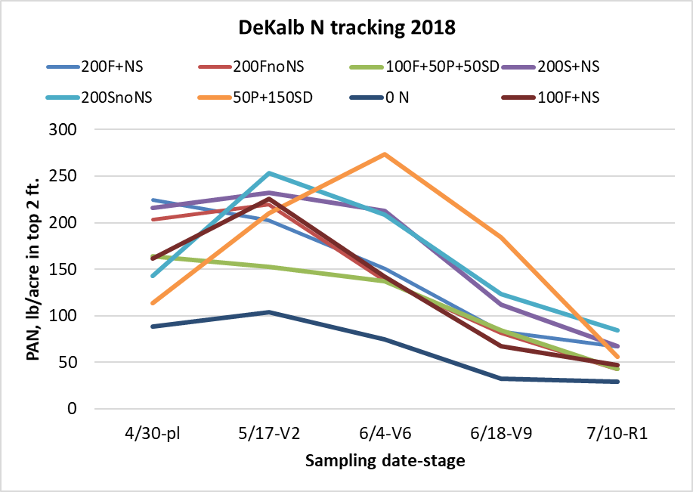

Figure 1. Soil N following application of N at different times and forms, DeKalb, 2018.

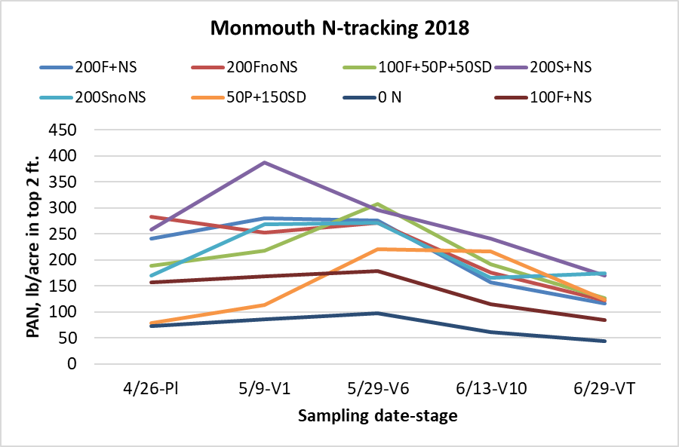

Figure 2. Soil N following application of N at different times and forms, Monmouth, 2018.

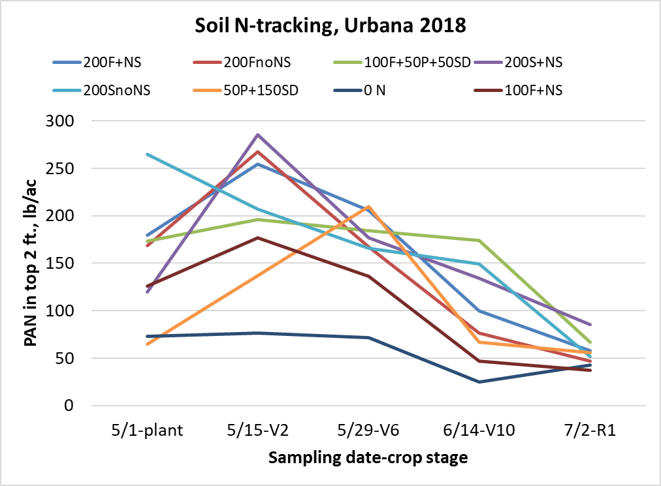

Figure 3. Soil N following application of N at different times and forms, Urbana, 2018.

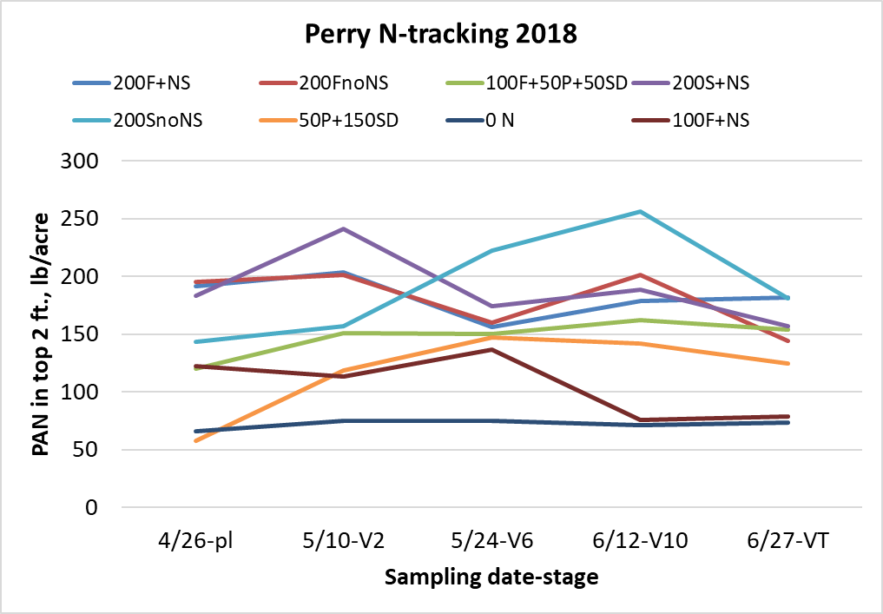

Figure 4. Soil N following application of N at different times and forms, Perry, 2018.

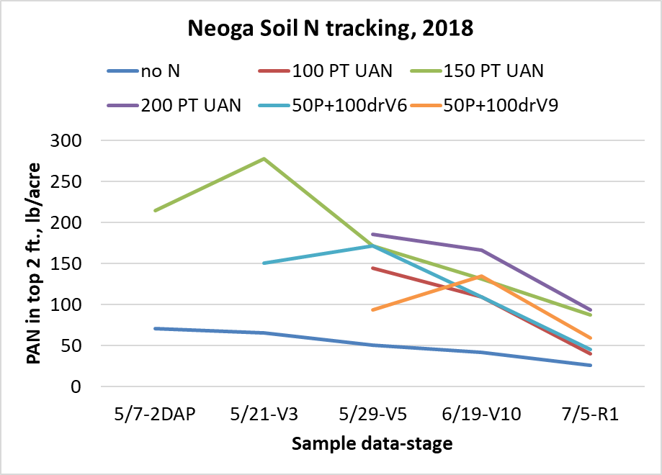

Figure 5. Soil N following application of N at different rates, times and forms, Neoga, 2018.

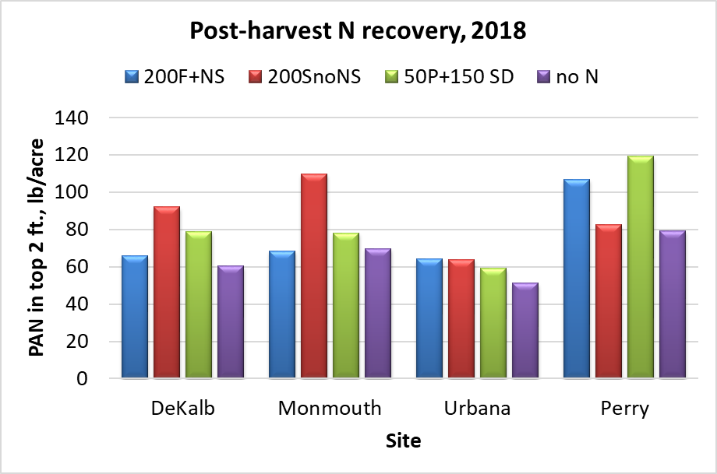

Figure 6. Soil N following application of N at different times and forms at the four research center sites in 2018.

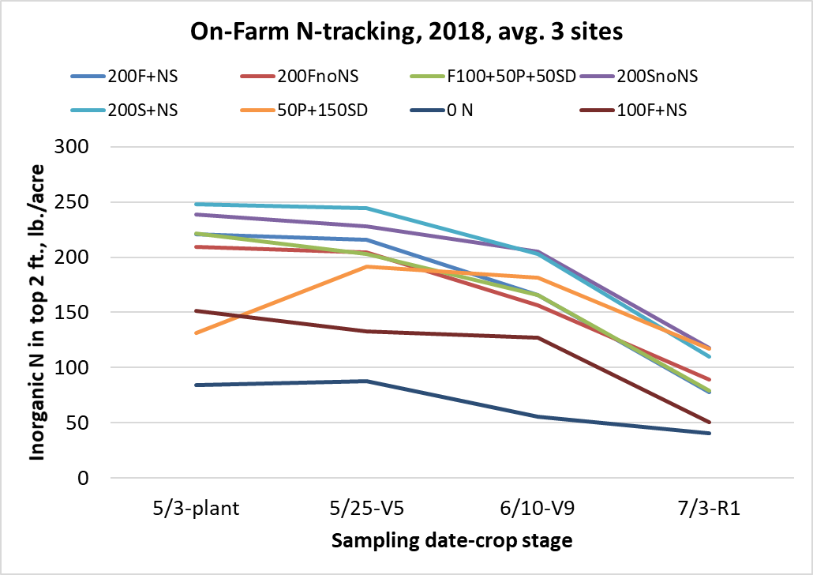

Figure 7. Soil N following application of N at different times and forms averaged across three on-farm sites in 2018.

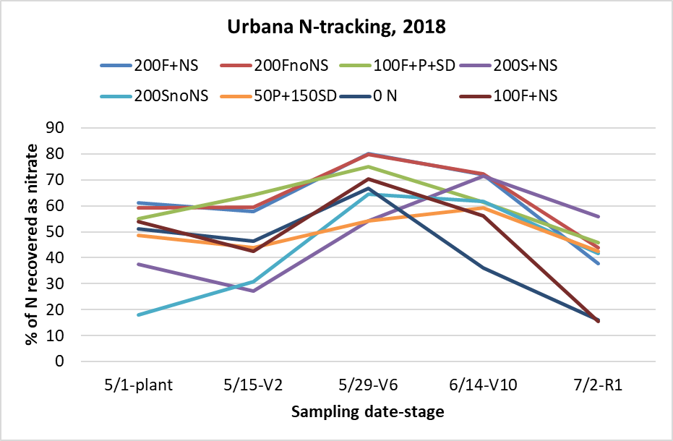

Figure 8. Percentage of N recovered as nitrate at Urbana, 2018.

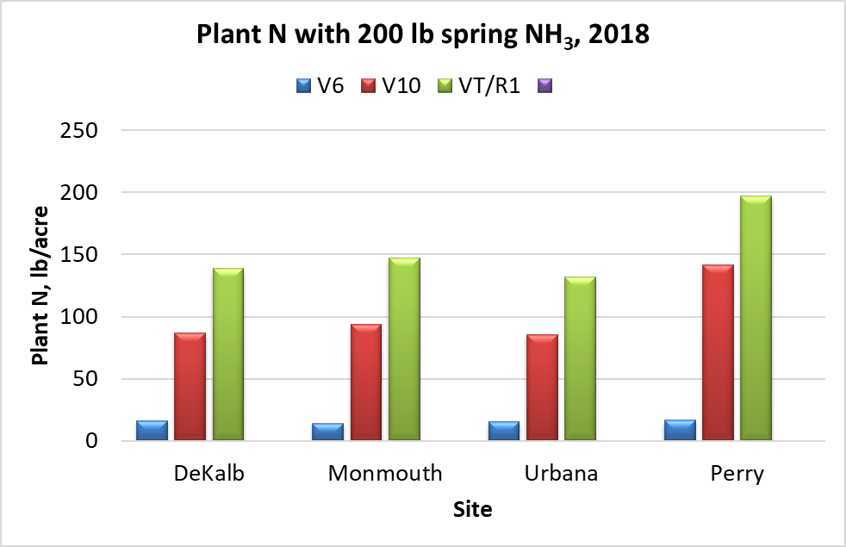

Figure 9. Plant N content by site at different sampling stages in 2018.

Table 1. Corn yields with different N forms and timings in the N-tracking sites on and across RECS in 2018. Numbers followed by the same letters within a location aren’t significantly different at p=0.10. PT = planting time UAN; SD = sidedress UAN at V5-V6; both injected.

|  |  |  |  |  |  |  |  |  |  |  |
| --- | --- | --- | --- | --- | --- | --- | --- | --- | --- | --- |
| Treatment | DeKalb | | Monmouth | | Urbana | | Perry | | Avg. 4 sites | |
|  | ----------------------------------------bushels per acre----------------------------------- | | | | | | | | | |
| Fall NH3 + N-Serve | 233 | a | 258 | a | 242 | a | 207 | a | 236 | a |
| Fall NH3 no N-Serve | 230 | ab | 254 | ab | 224 | b | 203 | ab | 228 | b |
| Fall 100 NH3+N/PT50/SD50 | 219 | abc | 252 | abc | 244 | a | 207 | a | 231 | ab |
| Spring NH3 + N-Serve | 229 | ab | 252 | abc | 238 | a | 201 | abc | 230 | ab |
| Spring NH3 no N-Serve | 227 | ab | 249 | bc | 240 | a | 197 | bcd | 229 | ab |
| P50 UAN+Sidedress 150 UAN | 214 | bc | 245 | c | 222 | b | 193 | cd | 219 | c |
| 100 lb fall NH3+N-Serve | 206 | c | 228 | d | 212 | b | 191 | d | 209 | d |
| No N applied | 131 | d | 168 | e | 121 | c | 143 | e | 139 | e |

Table 2. Corn yields with different N forms and timings in the on-farm N-tracking sites in 2018. Numbers followed by the same letters within a location aren’t significantly different.

|  |  |  |  |  |  |  |  |  |
| --- | --- | --- | --- | --- | --- | --- | --- | --- |
| Treatment | Ford Co. | | McLean Co. | | Christian Co. | | Avg. 3 sites | |
|  | ------------------------bushels per acre----------------------- | | | | | | | |
| Fall NH3 + N-Serve | 242 | b | 276 | a | 281 | ab | 266 | ab |
| Fall NH3 no N-Serve | 254 | ab | 268 | a | 285 | ab | 269 | ab |
| Fall 100 NH3+NS+PT50+SD50 | 248 | ab | 276 | a | 269 | ab | 264 | ab |
| Spring NH3 + N-Serve | 246 | b | 264 | a | 294 | a | 268 | ab |
| Spring NH3 no N-Serve | 271 | a | 278 | a | 282 | ab | 277 | a |
| PT50 UAN +Sidedress 150 UAN | 260 | ab | 257 | a | 241 | b | 253 | b |
| 100 lb fall NH3+N-Serve | 243 | b | 254 | a | 272 | ab | 257 | ab |
| No N applied | 88 | c | 170 | b | 112 | c | 123 | c |